In-class example 1: Worms

- The following are tables from Miguel and Kremer’s paper on worms. Answer the following questions based on “any moderate-heavy infection, 1999” after the deworming program in the first year.
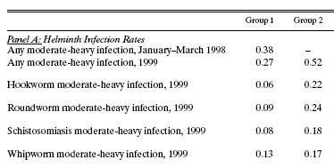

  - What is the intention to treat effect of the deworming program on having any moderate-heavy hookworm infection in 1999? (3)

  - What is the treatment on the treated effect of taking the pills on having any moderate-heavy infection in 1999? (3)

  - What is the identification assumption by which our estimate in (b) is internally valid? (3)

  - What is the within school externality (in other words, what is the effect of being untreated in the treatment schools on having any moderate-heavy infection in 1999)? (3)

- The authors estimate the following regressions to measure within school externalities and across school externalities:

  - What is the identification assumption to estimate the across school externalities? (2 points)

  - What might be one threat to the assumption in (a)? (2 points)

Using the table below and the estimated coefficients in columns 1 and 2:

  - Column 1: Interpret gamma_d, using the numerical value in the sentence. (2 points)

  - Why do the authors include N_dit? (2 points)

For the next four questions, see the table from the paper at the end of the worksheet.
  - Column 1: Interpret beta_1, using the numerical value in the sentence. (2 points)

  - Column 2: Interpret beta_1, using the numerical value in the sentence. (2 points)

  - Column 2: Interpret b_2, using the numerical value in the sentence. (2 points)

  - Column 2: Interpret b_1, using the numerical value in the sentence? (2 points)

